Akai MPK2 Series - Setup in Steinberg Cubase

The Akai MPK2 series controllers combine deep software integration, enhanced workflow, and core technologies from the iconic line of MPC workstations. The MPK225, MPK249, and MPK261 are engineered to be all-in-one controller solutions for comprehensive interfacing and manipulation of virtual instruments, effect plugins, DAWs, and more. This articles walks through how to setup the MPK2 series controller with Steinberg Cubase.

Contents
- MPK2 Series Hardware Setup
- Cubase Software Setup
- Virtual Instruments and Plugins
  - Adjusting the Cubase Plugin Sources
  - Default Plugin Installation Locations
  - AIR Hybrid 3
  - SONiVOX Twist 2
  - SONiVOX Eighty Eight Ensemble 2
- Additional Resources
- Further Technical Support

Hardware Setup
- First, connect the Akai MPK2 series controller to an available USB port on your computer using the supplied cable and power the controller on.
- Press the PRESET button and use the data dial to scroll to Preset: 10 Cubase. Press the PUSH TO ENTER knob.
Note: The presets, preset names, and order of presets may vary depending on the specific model.

- Press the GLOBAL button to enter the Global settings menu. Press the right arrow key until the display reads Clock Source: Use the rotary knob to select External.

- Hit the right arrow key until the display reads Save Globals. Press the PUSH TO ENTER knob to save the settings. The display will flash . When this is complete, the display will read .

- Press the PRESET button to return to the Cubase preset screen.
Back to Top

Software Setup
- Open Steinberg Cubase.
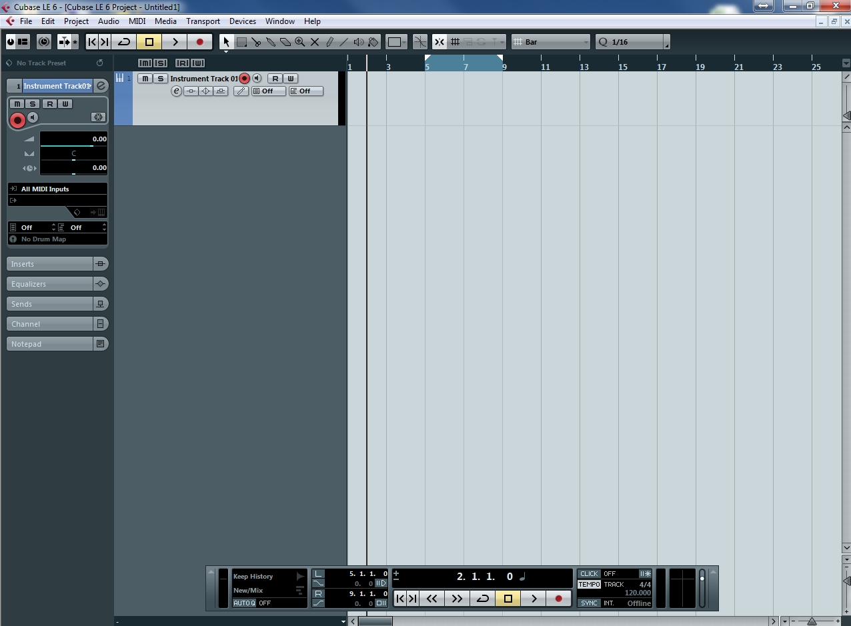
- From the top menu, choose Devices > Device Setup...
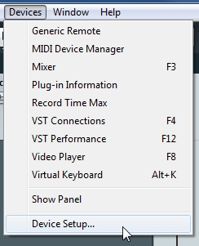
- In the window that opens, click on the + (plus) button in the upper-left corner and choose Generic Remote from the drop-down list to add a remote device.
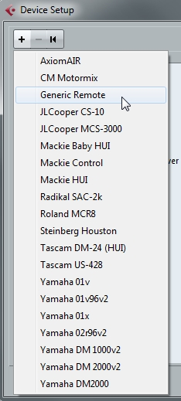
- Ensure that Generic Remote is highlighted in the left portion of the window and then choose your MPK2 series controller in the drop-down menus next to MIDI Input and MIDI Output in the center-top of the window.
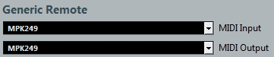
- Download the Cubase preset setup file from this link. Unzip the download, locate the .xml preset file and note where you have it saved it on your computer.
- Back in Cubase, on the right side of the Device Setup window, choose the Import button.
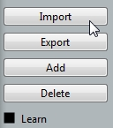
- In the window that opens, locate the Cubase preset .xml file and press Open.
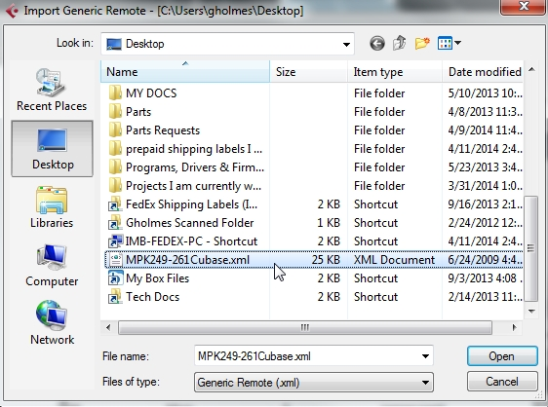
- Back in the Device Setup window, press Apply, then press OK.
- Finally, to ensure Synchronization for functions such as the Arpeggiator, choose Transport > Project Synchronization Setup...
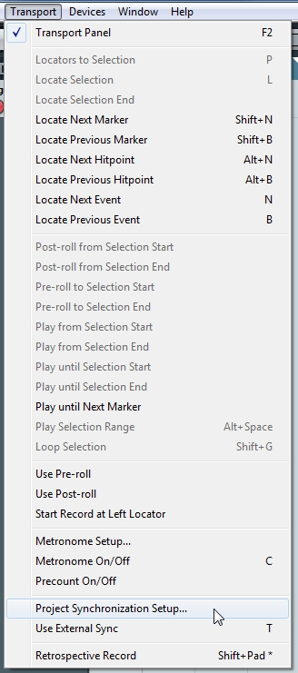
- Under Timecode Source, choose Internal Timecode. Within MIDI Clock Destinations, choose MPK249.
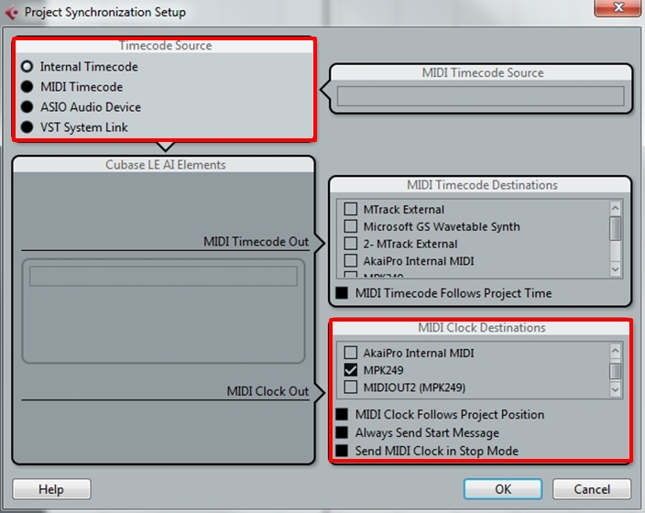
Back to Top

Virtual Instruments and Plugins

Adjusting the Cubase Plugin Sources
Note for Windows users only: If you have difficulty locating a plugin within the Steinberg Cubase software, be sure Cubase is reading plugins from the correct location where your plugins are installed. To do this:

  - From the top menu toolbar in Steinberg Cubase, choose Devices > Plug-in Information.
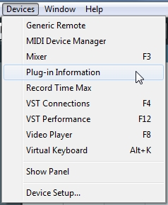
  - In the window that opens, click on the VST Plug-ins tab, then choose the VST 2.x Plug-in Paths button.
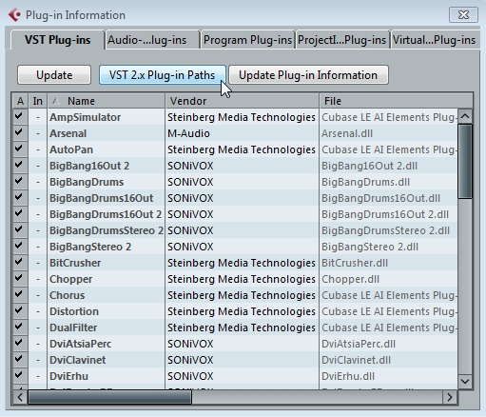
  - In the next window, choose the Add button, browse to the correct plugin folder location and press OK. Finally, press OK in the VST 2.x Plug-in Paths window, then close the Plug-in Information window.
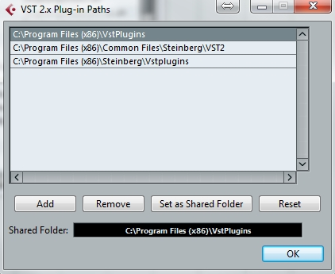
Back to Top

